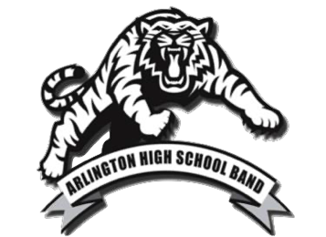
Dear Parents, The Arlington High School Band Arlington High School
5475 Airline Road
Arlington, TN 38002
www.ahstigerband.com
Welcome to the 2020-2021 Arlington High School Band family! We call ourselves a “family” because we will spend a lot of time together this year during football season, band contests, and many other band events & activities. The band students will form bonds with one another like brothers and sisters in a family. The band room will be your child’s home away from home and a safe haven before and after school. Since you have a child in the AHS band program, you are part of the band booster family too. The band students have a lot of work ahead of them this year and we want to make sure that this is an enjoyable, memorable year for everyone!
The AHS Band Booster program is designed to support the band directors, band staff and the band students. We are the support system for the band working behind the scenes to make sure the band program is a success. Throughout the 2020-2021 year, there will be plenty of opportunities for volunteering. Volunteering not only helps keep all of the band activities running smoothly but also allows us all to get to know one other as well. We have many volunteering needs and some require very little time to more time depending on the needs. Some examples include: chaperoning, concessions, band camp, Arlington Open Invitational, pit crew, after school band practices, uniforms & alternations, marching band competitions and so much more. If you have a special skill/talent such as carpentry or sewing or any other skills that you can offer to the band program, then please let us know. Please consider volunteering!
Most importantly, please be engaged in the band program by taking the time to stay informed of all of the important activities that will occur over the 2020-2021 year. Take pride in the band program and find out what is happening. No one should ever say, “I didn’t know about that.” We have a Facebook page currently noted as AHS Band 2019-2020: No Beginning, No End. If you haven’t joined our FB page, then please join now. We have a band website at www.ahstigerband.com which will have important information posted throughout the year. We also have a few Remind apps that we strongly encourage you to join. You can go to the band website and click on the Remind button you wish to join. Please be sure to join both Band and Parent Reminds in order to get the latest updates. Please be sure to also take the time to read emails from the Band Boosters since these will also contain important band information. We want you to be involved and we want this to be a fun and memorable year for our kids and for you! You can have fun too! It’s going to be a fantastic year, so stay tuned for upcoming announcements!
If you have any questions, then please feel free to contact any one of the Booster Board members at ahstigerbandboosters@gmail.com. We will help in any way we can.
WELCOME TO THE FAMILY!
The AHS Band Booster Board

